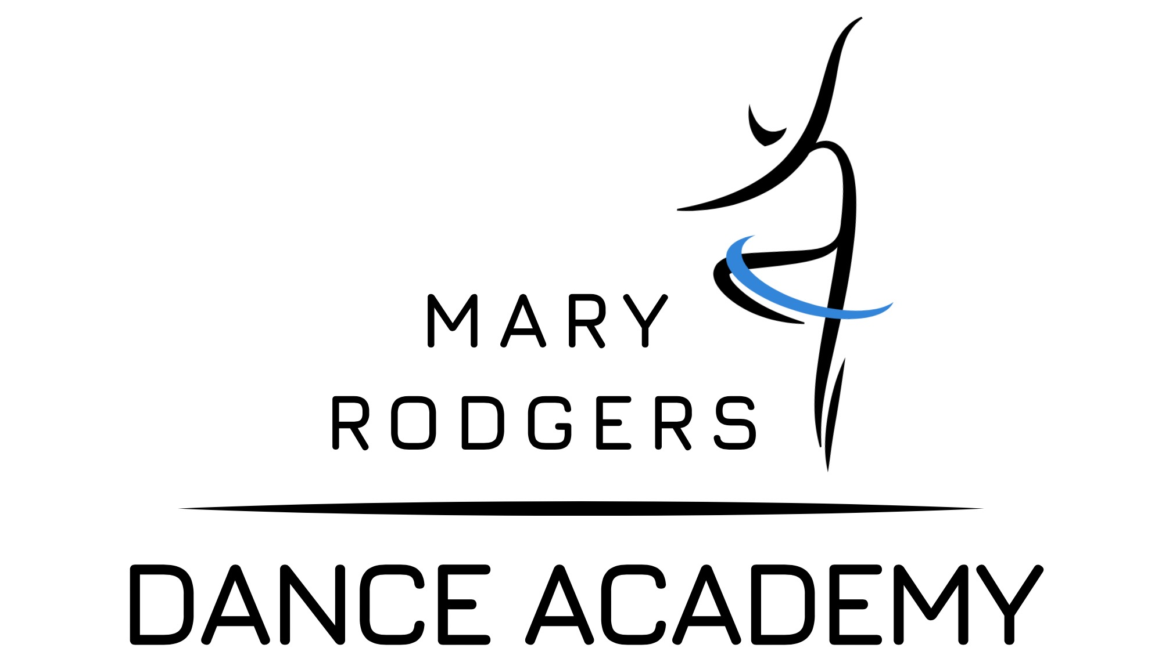
CONCERT TICKET ORDER FORM
ADULTS $25 CHILDREN $15
Student Name:

Class:

Contact Person - Mobile Phone Number:

Please indicate how many tickets you would like:
Tuesday 4th December 6pm:
Adults $25 Children $15

Wednesday 5th December 6pm:
Adults $25 Children $15

Thursday 6th December 6pm:
Adults $25 Children $15

Seating Preferences: (e.g. Wheelchair access)

TOTAL AMOUNT ENCLOSED $

Ticket orders will not be processed until costume hire has been paid

Cheque or cash only - NO INTERNET BANKING

